FOR IMMEDIATE RELEASE
updated-12/27/2021

ElecJet Apollo Ultra - The Fastest Charging Power Bank in The World

From Nobel-Prize winning graphene technology to a battery with a 5 times longer life cycle than its competitors, Elecjet hits Indiegogo to claim the title of the “Fastest Charging Power Brank The World Has Ever Seen”.

November 24, 2021, Elecjet is proud to announce the highly anticipated launch of Apollo Ultra - the world’s fastest charging power bank with a charging speed of 27 minutes and a capacity three times larger than your phone. Developed by UC Berkeley alumni, Sam Gong, Elecjet’s Apollo Ultra is the first power product to utilize real graphene on a large scale combining record-breaking ultra-fast charging and ultra-long life cycles in a slim and compact design.

To reach numbers that might seem unrealistic, Elecjet used revolutionary graphene material - a near-perfect conductor of electricity to create its own proprietary battery that charges 5x faster and lasts 5x longer when compared to current lithium batteries. In combination with its ultra-advanced power technology, the Apollo Ultra is ready to serve record-breaking speed numbers of 7 minutes to power your phone or 27 minutes for a full charge.

Besides boosting unreachable speed numbers, graphene material enables sustainable and environmentally friendly battery usage by gifting Apollo Ultra with 2,500 life cycles as opposed to 500 life cycles offered by power banks with lithium batteries. This means that the batteries in the Apollo Ultra live 5 times longer and have 5 times less environmental impact, creating an eco-friendly solution for tech users.
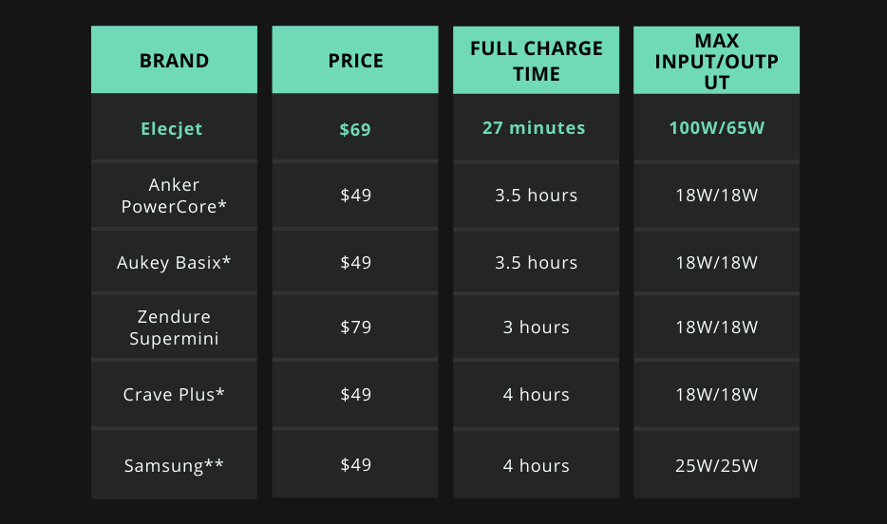
*https://www.powerbankexpert.com/best-10000mah-power-bank/
**https://www.samsung.com/us/mobile/mobile-accessories/phones/10000-mah-portable-battery-with-micro-usb-cable-silver-eb-p1100bsegus/

As for the competition, Apollo Ultra is beyond comparison taking the lead in the power bank industry with its groundbreaking features. In the chart below, you can find the specs of Elecjet in contrast with its closest competitors that are in the 10Ah category.

How can you tell that graphene is being utilized in the battery?

The real power of the battery is expressed in the C rate and not the wattage. The C rate is the rate of time it takes to completely charge or discharge a battery. 1C is 60 minutes, 3C is 20 minutes (or 1hour divided by 3), 0.5C is 2 hours (or 1hour divided by 0.5) - the larger the C rate the faster the battery speed. Size doesn’t affect the speed of charging as C rate and battery power is a ratio relative to its capacity.

Current industry batteries that are “quick charging” are between 0.5 C and 1 C meaning in a lab setting, they charge in 1.5 to 2 hours. However, in real-life applications, it takes much longer resulting in charging times that can go upwards of 3 hours. The Apollo Ultra’s battery is 3C charging meaning that it fully charges in 20 minutes in a lab and 27 minutes in a real-life application.

However, wattage utilization is also a key factor. The Apollo Ultra fully utilizes its 100W charging throughout the entire charging process until the last few percentages of charging. 10Ah is 37Wh and using basic math, the battery should fully charge in 23 minutes (37Wh/100W=0.37 hours) which is very close to the 27 minutes we get.

The media is obsessed with ElecJet
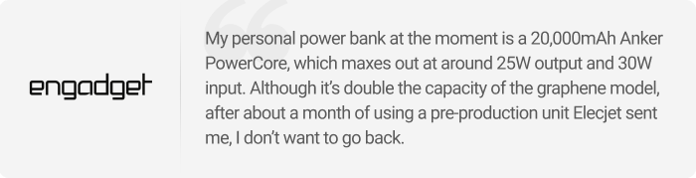
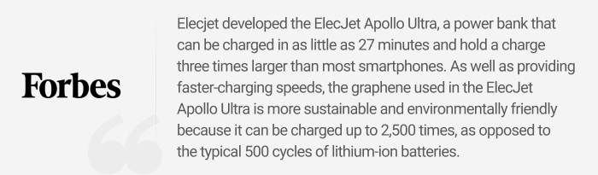

Availability

ElecJet Apollo Ultra is available to back on Indiegogo with a starting price of $69.

About the company

Elecjet started operations in late 2019, specializing in super-fast charging power solutions. In early 2021, Real Graphene merged with Elecjet bringing together advanced battery technologies from Real Graphene and advanced power technologies from Elecjet.

Now led by UC Berkeley alumni, Samuel Gong, Elecjet holds over 9 patents in fast-charging battery solutions for both hardware and software. Elecjet was also recently accepted into the NewChip accelerator to turn Elecjet into a formidable battery industry disruptor currently starting a post-revenue Seed Round.

Most importantly, Elecjet is a battery solutions company. The power bank is a demonstration of amazing technologies such as graphene batteries that can be scaled up to various applications. A few examples of ongoing partnerships with Elecjet are power solutions for smart wearables and electric vehicles.

Elecjet has a reputable history of always producing high-quality products. Elecjet is currently one of the fastest-growing sellers on Amazon and an official Amazon Vendor. With Ratings on all of its products are at least 4.6 and 4.7 stars over hundreds of genuine reviews, Elecjet is a power to be reckoned with. The catalog of previous Elecjet products can be found here.

For Press inquiries
Artak Mkrtichyan
artak@tcf.team

